Тематические тесты по английскому языку. 5 класс.

Цель настоящих тестов - познакомить учащихся 5 классов с заданиями в формате ГИА, заранее начать систематическую подготовку и тренировку по 2 разделам с заданиями (чтение, грамматика и лексика). Задания каждого раздела нацелены на развитие у учащихся соответствующих языковых умений и навыков.

Материал текстов подбирался с таким учетом, чтобы в доступной форме восполнить пробелы, связанные с нехваткой сведений по страноведению Великобритании в школьных учебниках по английскому языку, разнообразить учебный процесс и развивать у школьников интерес к изучению английского языка. Тесты могут быть использованы к любым учебным программам. Все тексты снабжены иллюстрациями.

**Раздел «Чтение»** включает 3 вида заданий, из которых первое - на установление соответствия и два других - выбор правильного ответа из ряда предложенных.

**В задании №1** необходимо подобрать заголовки или подходящий ответ на вопрос (A, B, C, D, E) к коротким текстам. Перенести ответы в таблицу.

**В задании №2** необходимо выбрать к каждому утверждению один из трех ответов: «Верно» (a - True), «Неверно» (b - False), «В тексте не сказано» (c - Not stated). Перенести ответы в таблицу.

**В задании №3** необходимо выбрать из четырех предложенных вариантов ответа тот, который соответствует содержанию текста (a, b, c, d). Перенести ответы в таблицу.

**Раздел «Грамматика и лексика»** включает 3 вида заданий. При выполнении упражнений учащимся необходимо показать хорошее знание пройденных слов, знание грамматических правил.

**В задании№1** даны тексты с пропусками. В эти пропуски надо вставить слова и выражения (a, b, c, d, e), чтобы получился полный текст. Слова и выражения даны перед каждым текстом.

**В задании №2** даны тексты с пропусками. Справа жирным шрифтом даны слова, которые надо поставить в правильную форму, чтобы заполнить пропуски.

**В задании №3** необходимо выбрать из четырех предложенных вариантов ответа (a, b, c, d) ту грамматическую форму, которая соответствует содержанию текста.

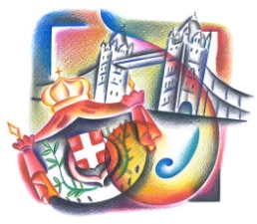

5 f. Reader 1.4. Прочитайте тексты (1-5) и найдите их соответствие с вопросами (А-Е). Занесите свои ответы в таблицу.

1. London is the capital of Great Britain, which stands on the river Thames. The West End is the center of London. There are a lot of theatres, cinemas, galleries and museums there.

2. The City of London is the oldest part of London. There are many banks, offices and firms in this part of London. It’s the financial center of the UK.

3. Tourists from all the countries of the world go shopping to Oxford Street, which is in the West End of London. They can buy all the things they want in its famous shops.

4. The East End of London is the district for the working people. There are many factories, workshops and docks (корабельные мастерские).

5. The political centre of London is Westminster. You can find many places of interest there. A long grey building with towers is the Houses of Parliament. The large clock in one of the towers is Big Ben. Big Ben is the name of the clock and the bell of the clock tower of the Houses of Parliament. People can hear the sound of Big Ben every hour in London.

Which part of London can be called…?

A. the hands of London

B. the time of London

C. the money of London

D. the goods (товары) of London

E. the culture of London.

|  |  |  |  |  |
| --- | --- | --- | --- | --- |
| 1 | 2 | 3 | 4 | 5 |
|  |  |  |  |  |

5 f. Grammar 1.10. Прочитайте текст. Заполните пропуски соответствующими по смыслу словами и фразами (a, b, c, d, e). Занесите свои ответы в таблицу.

a) London Bridge

b) have home

c) St. Paul’s Cathedral

d) city

e) houses

In the old city of London there were **narrow** streets with **wooden** houses. It was a dirty (1) ______. 75,000 Londoners died from **Plaque** **in 1665**.

**On the second of September**, **1666** there was a strong wind from the river and a big **fire** began. It started in the house of the king’s **baker** near (2) ______. After a long summer the wooden (3) _____ were dry. Soon the next house started **burning** and then the next and the next …

The fire **burned** for four days. It destroyed 80% of the city. More than 250 thousand people didn’t (4) ______ any more. But nobody died in the fire.

The people of London built a new city. The houses were made of **brick** or **stone**, not wood. The new streets became **wider** and **cleaner**. **Sir Christopher Wren** rebuilt (5) ______.

|  |  |  |  |  |
| --- | --- | --- | --- | --- |
| 1 | 2 | 3 | 4 | 5 |
|  |  |  |  |  |

Narrow (узкий); wooden (деревянный); Plaque (чума)

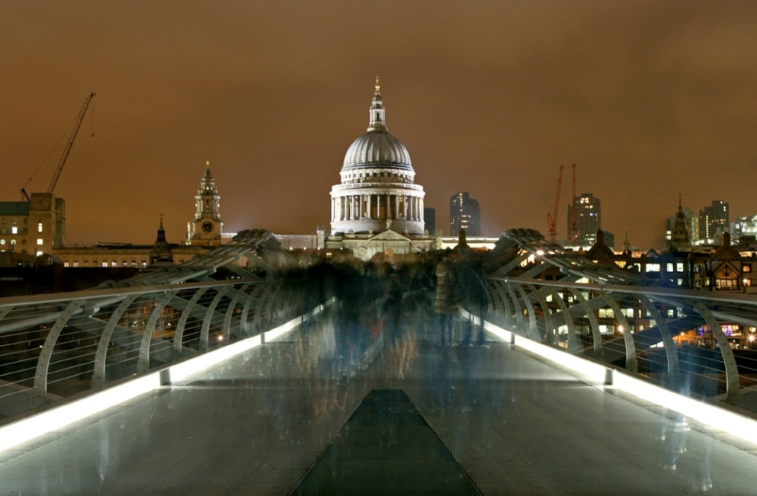

C:\Users\Anna\AppData\Local\Microsoft\Windows\Temporary Internet Files\Content.IE5\R3KZMQAZ\MC900390720[1].wmf

5 f. Reader 3. Прочитайте текст. Закончите предложения, выбрав правильный вариант (a, b, c, d). Занесите свои ответы в таблицу.

My name is David. I am ten. I come from the United Kingdom. I’m English and I live in the capital, London. **Queen Elizabeth** lives here too. She lives at **Buckingham Palace**. It isn’t very far from **10 Downing Street**, where **the Prime** **Minister** lives.

Lots of tourists come to London. The first place they visit is **the Tower of** **London**, which is nine hundred years old. It’s got **Beefeaters**, **ravens**, **the crown** **jewels** (королевские сокровища) and **ghosts**!

Beefeaters don’t eat beef. They protect the Tower. The name Beefeater comes from when the Queen gave them meat, not money, as their pay (плата). Now forty Beefeaters live in the Tower.

The Tower has got many ghosts. There are ghosts in **the Salt Tower**. Beefeaters and dogs don’t like to go there at night.

There are seven ravens in the Tower if they fly away from it, it is bad luck (беда) for London. Every day they eat meat, eggs and cakes.

There is a special room for the crown jewels. The crown has got three hundred jewels on it, but the Queen only wears the crown once every year!

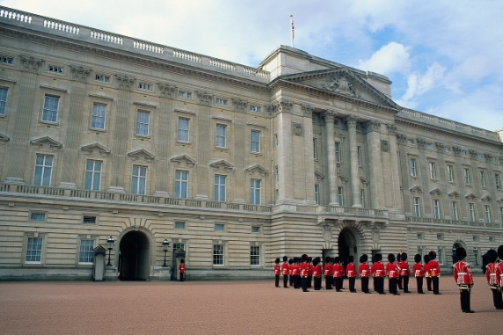 C:\Users\Anna\AppData\Local\Microsoft\Windows\Temporary Internet Files\Content.IE5\HSZ6B2EY\MC900198296[1].wmf

**1. British Prime Minister lives**

a) in London, in Buckingham Palace

b) in the United Kingdom, in the Tower

c) in London, at ten Downing Street

d) in the UK, at seven Downing Street

**2. The Tower of London is**

a) 800 years old

b) 900 years old

c) 1000 years old

d) 2000 years old

**3. The Beefeaters got their name because**

a) they eat much meat

b) they give meat to the ravens

c) they cook meat for the Queen

d) they didn’t get the money, they got meat

**4. it’s bad luck for London if,**

a) ghosts fly away

b) ravens eat cakes, meat and eggs

c) ghosts come back

d) ravens fly away

**5. there are three hundred jewels**

a) on the Queen’s crown

b) in a special room

c) in the Salt Tower

d) in the Queen’s Palace

|  |  |  |  |  |
| --- | --- | --- | --- | --- |
| 1 | 2 | 3 | 4 | 5 |
|  |  |  |  |  |

5 f. Grammar 2.9. Прочитайте текст. Измените слова, стоящие справа, так, чтобы они грамматически соответствовали содержанию текста. Занесите свои ответы в таблицу.

The black London taxi cab (1) _____ a traditional symbol of London. be It (2) ______old- fashioned (старомодный) and clumsy, but in fact it's look comfortable and speedy. Besides, London taxi (3) ______ know the city driver very well. They spend up to two years studying and learning the names of 25.000 streets. They also must know very (4) ____ where hospitals, good hotels, theatres, clubs, museums, etc. are. Then they have to pass a very difficult test. So when you get into the famous black cab you can be absolutely sure that it’ll take you wherever you want and by the (5) ____ quick possible way.

|  |  |  |  |  |
| --- | --- | --- | --- | --- |
| 1 | 2 | 3 | 4 | 5 |
|  |  |  |  |  |

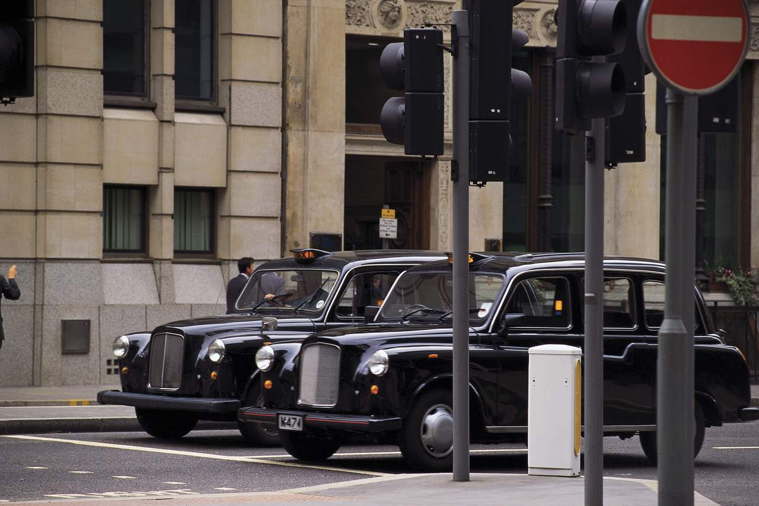

**5 f. Grammar 2. Прочитайте текст. Измените слова, стоящие справа, так, чтобы они грамматически соответствовали содержанию текста. Занесите свои ответы в таблицу.**

Many people have pets - guinea pigs, parrots, cats and dogs. They (1) _______ like members of our families. be

In England many years ago farmers showed the same love for their horses. Some farmers even (2) ________their horses with decorate flowers. Robbin, Dobbin and Hobbin were the names, which farmers (3) _____ to their horses most often. The name Hobbin give was changed into Hobby. It became the word for toy horses - **hobbyhorses.**

And only many years later people began to use the word hobby. In (4) ________ modern meaning - “something that you do when it you have free time and something that you like (5) ______ of all.” much

|  |  |  |  |  |
| --- | --- | --- | --- | --- |
| 1 | 2 | 3 | 4 | 5 |
|  |  |  |  |  |

C:\Users\Anna\AppData\Local\Microsoft\Windows\Temporary Internet Files\Content.IE5\9WTNDWLE\MC900297905[1].wmf

C:\Users\Anna\AppData\Local\Microsoft\Windows\Temporary Internet Files\Content.IE5\1RX8MD84\MC900437571[1].wmf

*Lexical test*  **Fill in the correct words or word combinations.** 3.2. Прочитайте текст. Выберите ответ (a, b, c) по смыслу. Занесите свой ответ в таблицу.

People like (1) ___. They travel on business or for pleasure. There are many (2) ___ of travelling: **plane**, **train**, **ship** or **boat**, **car** and **bicycle**. Some people travel on (3) ____. They ***go hiking***. Plane is the (4) ____ means of transport. Train is not very fast, but it’s (5) ____. When people go on excursions they travel by(6) _____. Car is the most popular method of travelling. It is convenient and comfortable. You (7) _____ travel by car everywhere you like. Many people travel ***by car*** to many places. Ships(8) _____seas and oceans. People travel ***by ship*** for pleasure. (9) ____ people are fond of travelling ***by bicycle***. It’s not (10) _____, but it’s safe.

1 a) travelling b) watching c) riding

2 a) maps b) means c) beans

3 a) bike b) plane c) foot

4 a) slowest b) fastest c) cheapest

5 a) comfortable b) convenient c) different

6 a) bike b) bus c) plane

7 a)can b) must c) would

8 a) cross b) open c) find

9 a) any b) no c) some

10 a) cheap b) different c) fast

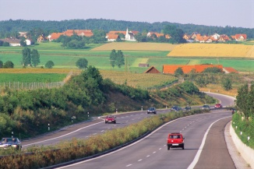 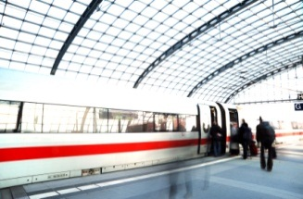 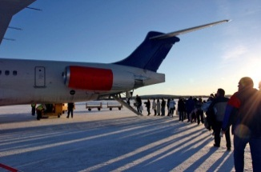 

*Lexical test* **Choose the correct word.** 3.3. Прочитайте текст. Выберите ответ (a, b, c) по смыслу. Занесите свой ответ в таблицу.

The (1) ___ of Great Britain and Northern Ireland is situated on **the British Isles**. The largest islands are **Great Britain** and **Ireland**. **England**, **Wales**, and **Scotland** are in (2) _____. **England** is in ***the* *central part*** of Great Britain. The capital of England is (3) _____. **The symbol** of England is the red (4) __. England is a magic country with beautiful landscapes, cities and villages. England is famous (5) ______ its charming places. **Wales** is in ***the south-west*** with its capital **Cardiff**. The symbol of Wales is the daffodil. **Scotland** with its capital **Edinburgh** is also very popular with tourists from other countries. The symbol of Scotland is the thistle.There are many old (6) ___, amazing landscapes and romantic lakes. The national musical instrument is a (7) _______. Some men wear a traditional (8) ______. **Northern Ireland** is situated not (9) ______ from the British Isles. The capital of Northern Ireland is **Belfast**. The (10) _______ of Ireland is the shamrock.

1 a) United Kingdom b) Kingdom c) Great Britain

2 a) England b) Great Britain c) Wales

3 a) London b) Cardiff c) Edinburgh

4 a) daffodil b) rose c) thistle

5 a) from b) about c) for

6 a) castles b) houses c) buses

7 a) drum b) trumpet c) bagpipe

8 a) shirt b) skirt c) kilt

9 a) long b) far c) near

10 a) symbol b) badge c) flag

|  |  |  |  |  |  |  |  |  |  |
| --- | --- | --- | --- | --- | --- | --- | --- | --- | --- |
| 1 | 2 | 3 | 4 | 5 | 6 | 7 | 8 | 9 | 10 |
|  |  |  |  |  |  |  |  |  |  |

C:\Users\Anna\AppData\Local\Microsoft\Windows\Temporary Internet Files\Content.IE5\08J9YW21\MC900430357[1].wmf C:\Users\Anna\AppData\Local\Microsoft\Windows\Temporary Internet Files\Content.IE5\XZHQW9LV\MC900398609[1].wmf  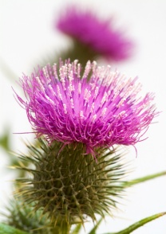

**The Normans**

Level B **Lexical test.** **Fill in the proper words.** 3.0. Прочитайте текст. Выберите ответ (a, b, c) по смыслу. Занесите свой ответ в таблицу.

The past of Britain is full of different (1) ____. Long ago England was (2) ______ by the Normans. The conquest of England began in 1066 with the battle of Hastings. The Normans were Vikings or “Norsemen”. They were very (3) ____ and aggressive warriors. They (4) _____ from a part of **France** opposite **England**. This (5) _____ is now called Normandy. The conquest gave England French kings and nobles. They brought **the French language**. There were three languages. **Latin** was (6) _____ of the church and the learned men. French was the language of the Kings and nobles. English was the language of the masses of people. (7) _____people didn’t understand French and Latin. Many (8) ____ from these languages came (9) _____ into English. Many English and French words are written in the same (10) ___ and their equivalents are alike.

1 a) adventures b) events c) actions

2 a) taken b) conquered c) caught

3 a) great b) strong c) funny

4 a) gone b) come c) came

5 a) place b) location c) playground

6 a) sentence b) language c) words

7 a) poor b) rich c) bad

8 a) sentences b) sounds c) words

9 a) next b) later c) sooner

10 a) road b) way c) street

|  |  |  |  |  |  |  |  |  |  |
| --- | --- | --- | --- | --- | --- | --- | --- | --- | --- |
| 1 | 2 | 3 | 4 | 5 | 6 | 7 | 8 | 9 | 10 |
|  |  |  |  |  |  |  |  |  |  |

